EXPERIMENT NO 7

Index.html
<!DOCTYPE html>
<html>
<head>
<title>Object to Array</title>
</head>
<body>
<h2>Create Object and Store in Array</h2>
<label>Enter Object Field Name:</label>
<input type="text" id="fieldInput"><br><br>
<label>Enter Object Field Value:</label>
<input type="text" id="valueInput"><br><br>
<button onclick="addObjectToArray()">Add Object to Array</button><br><br>
<button onclick="checkIfArray()">Check if Variable is Array</button><br><br>
<div id="arrayDisplay"></div>
<div id="checkDisplay"></div>
<script src="exp7.js"></script>
</body>
</html>

Script.js let myArray = []; function addObjectToArray() { const field = document.getElementById('fieldInput').value; const value = document.getElementById('valueInput').value;
let obj = {}; obj[field] = value; myArray.push(obj);
document.getElementById('arrayDisplay').innerHTML = `<strong>Array:</strong>
${JSON.stringify(myArray)}`; document.getElementById('fieldInput').value = ''; document.getElementById('valueInput').value = '';
}
function checkIfArray() { const result = Array.isArray(myArray);
document.getElementById('checkDisplay').innerHTML = `<strong>Is myArray an array?</strong> ${result}`;
}
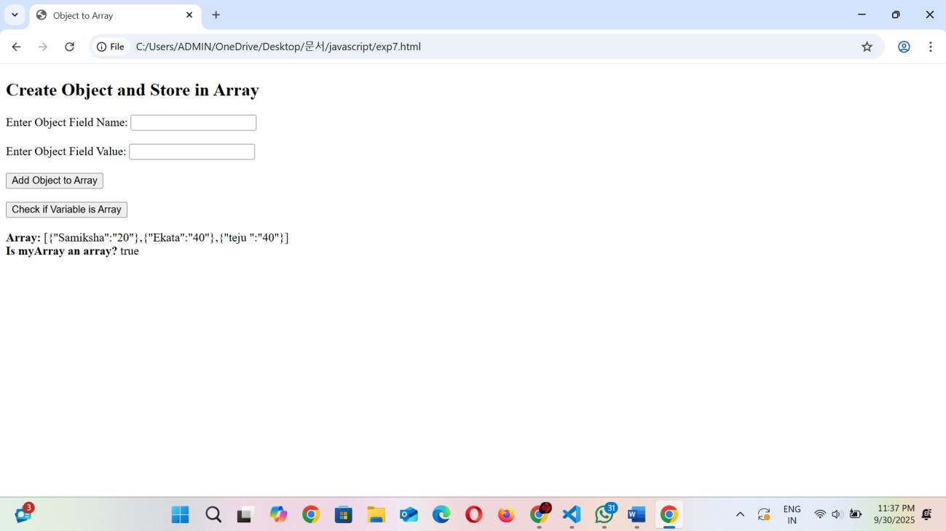
OUTPUT

